Introduction to measurement named
"Examination of Sound- and Picture Coding Processes with Methods of Remote Education"

Education of picture- and sound coding with multimedia
Béla Kalotay, Gyula Marosi

Introduction

Multimedia became a fashionable word. We hear it more and more frequently in connection with telecommunication products (software, hardware, or even a newspaper article). Taking the meaning of this word into consideration, we are entitled to expect from the given product to contain elements in connection with sound- and picture coding (or audio- and video coding, to be more up-to-date), transmission and storage, too. Although concept of multimedia cannot be narrowed just to these fields, it is evident, that these subjects also suit tightly to the domain of multimedia. Their studying, development has been started many years ago, with numerous serious results. Appearance of concept of multimedia meant a serious promotion for these researches and developments in one hand, and on the other hand, it had set a mutual aim.
In Budapest University of Technology and Economics (BME) subjects mentioned above have been educated for many years, but during the latest months a claim occurred for the development of a subject, which presents and involves the picture-, sound-, and other information transmission tasks applied in telecommunication into a system, grouping them around the concept of multimedia. During development of subject named Telematics and Multimedia a thought appeared, that during the education of this subject student should get acquainted as an experiment of a remote education with multimedia systems, which may help to gain practical experiences in connection with the subject in the laboratory, or at home in front of their own computers, learning the actual part of the subject.
There are sound-, picture-, and video materials in the technological toolbar of education since many years. Studying/educational methods applying these tools achieved a more and more professional level. Application of personal computers was predicted in education decades ago in science fiction literature. Technical conditions at the beginning of the years from 1990 allowed the generation of computered training materials. Multimedia PCs were issued, and this created an open road for the multitudinous spread of multimedia applications. Number of multimedia products, that mean a real remote education, is quite low yet nowadays, since tools are relatively young and development of materials of remote education requires a long time (approximately 1 or 2 years), and a great energy.
These factors motivated the development, wich is at the Department of Information Theory at Technical University of Delft in Holland, and resulted a program packet with demonstration and remote education purposes, presenting picture coding processes [1]. In Department of Telecommunication and Mediainformatics at BME a similar environment was developed, presenting coding processes of sound (and within this, studiously speech-) signals interactively [2].
Henceforward we will present the two softwares mentioned above, then we will show a multimedia environment, in which we can make interactive measurements with the help of demonstration program packets. We will also touch upon a special appearance of multimedia, which spreads apace at the worldspread international computer network, the Internet.

2. HDSP Demo program package
A demonstration program packet named High Definition Signal Processing nevû (HDSP Demo) was developed in 1991-93 atDepartment of Information Theory of Technical University of Delft for Sun-Sparc workstations, which is used, as a practical supplementary material of lectures of subjects teaching picture coding (e.g.: Coding for HDTV; Audio and Video Coding, etc.) This educational material generated with hundreds of engineering hours is enough for filling an intensive course lasting for a week. Taking possibilities of the target audience (students, participants of the course) we prepared the MS-Windows version of this program packet for IBM-PCs, which was developed according to the constraints given from the architecture [1]. Modules implementing the individual coding processes show the subject performed at the lectures in practice interactively and visually. Primitive coding steps can be examined with parameters set by the user him/herself (e.g. (sub-) sampling, quantization (errors), dithering, vector quantization, etc.); effects of transformation algorithms (e.g. sub-band coding, JPEG, MPEG). As an example, we can see the graphic handling surface of a module demonstrating the differential quantization (DPCM) on Figure 1. Figures 2./a,b,c,d demonstrate outputs belonging to different parameter- or option sets.

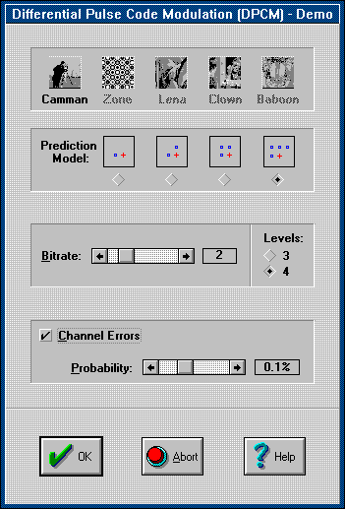

Figure 1. Graphic handling surface of DPCM module of HDSP Demo

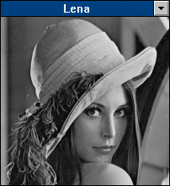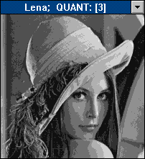

(a) (b)

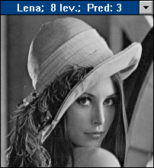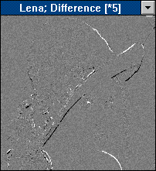

(c) (d)

Figure 2. PCM and DPCM coded pictures
(a) a 8-bit PCM input; (b) a 3-bit PCM output; (c) a 3-bit DPCM output; and
(d) difference between the input picture and the DPCM output picture

3. LASC Demo program packet
In the spring of 1994 Department of Telecommunication and Telematics at BME started the development of its demonstration software named Low Bit-rate Audio Signal Coding (LASC Demo), which is the functional equivalent of the picture coding program packet demonstrated above, for the demonstration effects of sound coding processes [3]. LASC Demo (as well as the picture coding demo mentioned above) has a modular build-up, allowing thus the development with modules demonstrating further coding processes, too. In the present state of development there are five modules at our disposal, which demonstrate effects of subsampling, quantization, differential quantization, sub-band coding and different distortions. This demonstration program packet will be flared in the near future with modules demonstrating adaptive DPCM coding, linear predictive coding, and vector quantization. For sake of comparability (and for sake of demonstration of similarity) Figure 3. demonstrates the graphic handling surface of DPCM module of LASC Demo. Figure 4. can demonstrate only one side of the possibility of audiovisual analysis of output waveforms; a standard MS-Windows compatible sound card is necessary for listening in PCs.

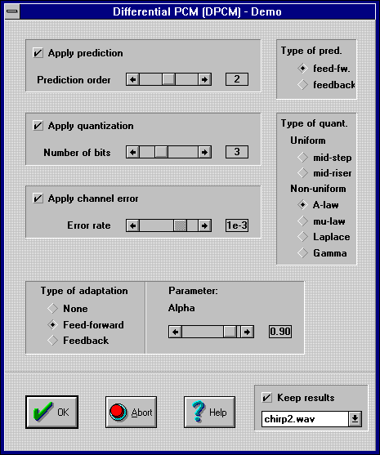

Figure 3. ábra Graphic handling surface of DPCM module of LASC Demo

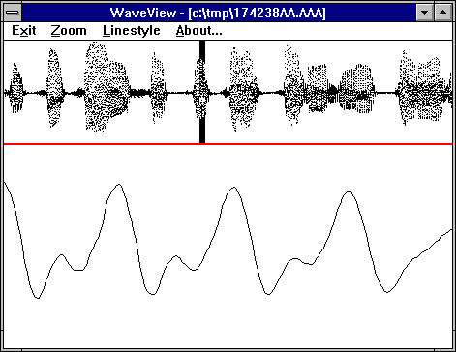

Figure 4. An output waveform in the WaveView program
We can see the marked section in the bottom window enlarged

LASC Demo contains a so called context-sensitive Help in a WinHelp hypertext format, which is well-known in the family of MS-Windows programs, namely in one hand we can get a description about the theoretical background of coding belonging to the given module, choosing Help on the graphic handling surface of any of the modules, and on the other hand about the parametering possibilities, the meaning of the individual parameters (according to the build-up of a typical Reference Manual). Figure 5. demonstrates a detail of the Help discussing theory of the Subsampling module.

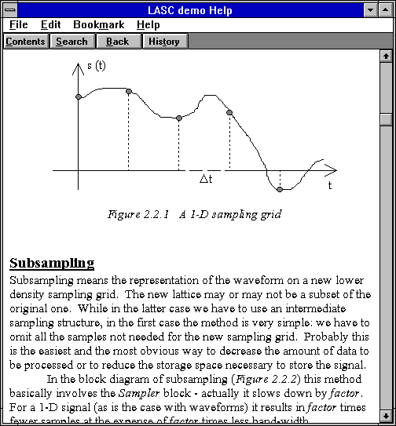

Figure 5. A detail from Help belonging to LASC Demo

4. Educational guide
There is an electronic booklet belonging to the program packet for students, which promotes and instructs the independent execution of demonstration appearing in the framework of practical education of the laboratory. Favourite tool of remote education programs is a program named ToolBook from Asymetrix [4], which operates in an MS-Windows environment, similarly to demonstration packets. Guidance of ToolBook belonging to LASC Demo gives only a short introduction to the individual modules, demonstrates the principle of operation (Figure 6.), and gives a guidance to starting. (It is equivalent to a typical Introduction és Getting Started chapters of a Users' Guide.) This booklet is distributed into turnable pages; pages are distributed into two spaces: touching the individual regions of the right side with a pointing tool (typically with the mouse), we can read an explanation, or a description belonging to this region on the left side. Figure 7. demonstrates a state of the page demonstrating DPCM module of LASC Demo.

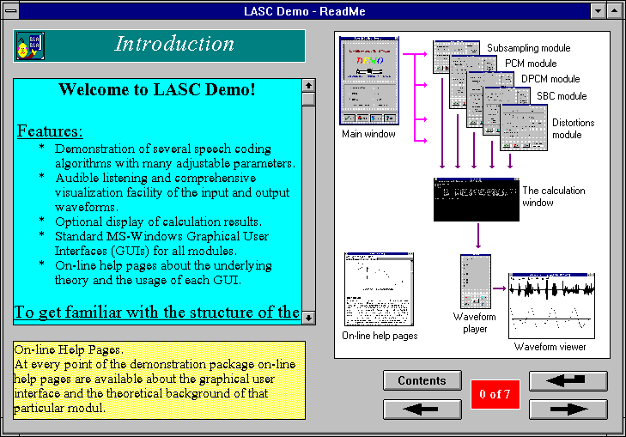

Figure 6. A short demonstration of the operation of LASC Demo in the ToolBook system

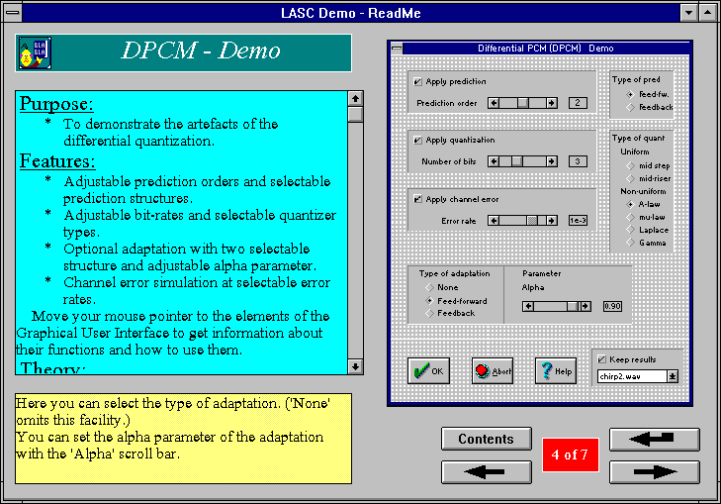

Figure 7. A ToolBook page demonstrating a module of LASC Demo

5. Remote education on a multimedia network
We can witness nowadays a great surge of development of a worldwide multimedia network. WWW (WorldWide Web) is a worldwide information system with a hypermedia supplementary, which has special centre computers (servers) providing information. We can put stationary and moving pictures, sound materials and texts to the hypertext documents in a html (HyperText Markup Language) format. They are available with the help of WWW browsers. One of the most famous browsers is the program of the NCSA named Mosaic, which was developed for different machines (PC, Mac, Sun, RS6000, HP, etc.) and for graphic systems (MS-Windows, X-Windows, etc.), too. A unique system (URL, Uniform Resource Locator) was developed to identify services and resources at the computer network, and for giving the access route, which hides different protocols of different servers.

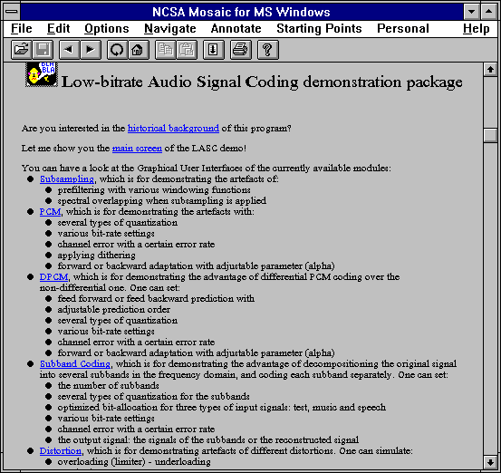

Figure 8. A page of WWW demonstrating LASC Demo

LASC Demo program packet introduces to users of the Internet as a commercial, if you like, with WWW browsers (e.g. Mosaic, Cello) in a “browseable” html format (its access route is the following (URL): http://luna.ttt.bme.hu/homepage.html). The introduction pagel (see Figure 8.) contains the short description of the individual module, their abilities, a relation to the aim of the project; all the pictures of the graphic user surface are available, as an illustration. Raising of the sound sample is tempting, too, but unfortunately there is no unity here yet: sound is stored in different formats on different servers, so browser are rarely able to play them back. Since there is no copyright for copying the content of the database, the whole system together with the proper documentation can be replaced anywhere only with pressing a button

6. Conclusion
During the latter years claim occurred at the Department of Telecommunication and Mediainformatics at BME for the development of a subject, which presents and involves the picture-, sound-, and other information transmission tasks applied in telecommunication into a system, grouping them around the concept of multimedia. During development of subject named Telematics and Multimedia a thought appeared, that during the education of this subject student should get acquainted as an experiment of a remote education with multimedia systems, which may help to gain practical experiences in connection with the subject in the laboratory, or at home in front of their own computers, learning the actual part of the subject.
It resulted the beginning of a development on the basis of a program packet (HDSP Demo) developed at Department of Information Theory at Delft University of Technology for the purpose of remote education and demonstration, introducing picture coding processes, for realization of a similar software (LASC Demo) illustrating interactively a similar process of signal coding (voice, and within it speech signal, strongly studiously). We have introduced the two demonstration program packet above - HDSP Demo and LASC Demo – in a nutshell. We have demonstrated a multimedia environment in connection with them with a ToolBook, in which we can make interactive, demonstrative measurements with the help of these program packets. We introduced a special form of multimediak, a hypermedia information system named WWW, which is spreading on the wordwide computer network, the Internet, and we have demonstrated the appearance form of these demonstration programs on this network..

Bibliography

[1]: Gy. Marosi: "A Video Coding Demonstration Package", Diploma Thesis, Delft Univeristy of Technology, 1993.
[2]: B. Kalotay, Gy. Marosi, P. Tatai: "Developing An Audio Coding Demonstration Package for Educational Purposes", Journal on Communications, 1994, (accepted for publication)
[3]: B. Kalotay, Gy. Marosi: "Low Bit-Rate Audio Signal Coding Demonstration Package", TEMPUS Konferencia, Budapest, 1994.
[4]: Antal Cs., Cselényi I., Ferenczi T., Szentiványi G.: "Általános Célú Szerzõi Rendszer Multimédia Alkalmazásokhoz", TDK 1993.

